Chapter 16 Review Exercise Solutions

R16.1

Insertion:
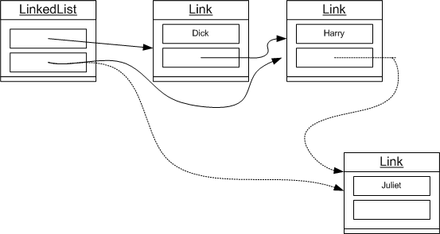
Removal:
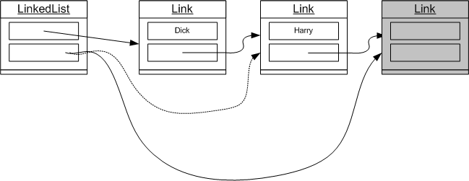
R16.2
Insertion:
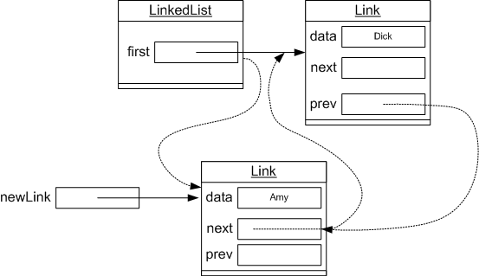
Removal:
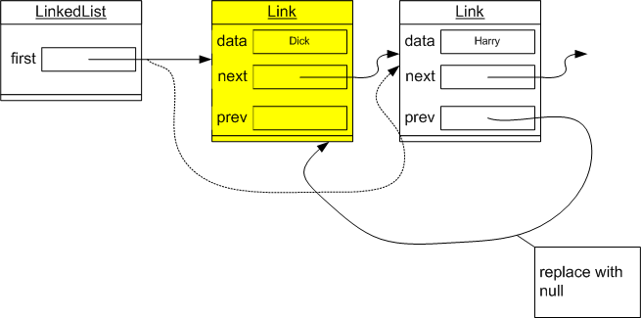
R16.3

Both are O(n) operations, where n is the length of the list.

R16.4

The first is an O(n) operation, but the second is O(n²) since removing an element is an O(n) operation.

R16.5

Correction: The problem statement should read "Instead, one can set the previous instance variable to a special value at the end of every call to add or remove."

It is tempting to set previous to null after a call to add or remove, but that doesn’t work. If one visits the first element, then previous is legitimately null.

Instead, one can set previous and position to the same value after each call to add or remove. This can never happen after a call to next. (After calling next, we either have previous == null and position == first, or previous != null and position == previous.next. In either case, previous != position.)

public void remove()
{
if (position == previous) { throw new IllegalStateException(); }
if (position == first)
{
removeFirst();
}
else
{
previous.next = position.next;
}
position = previous;
}

public void add(Object element)
{
if (position == null)
{
addFirst(element);
position = first;
}
else
{
Node newNode = new Node();
newNode.data = element;
newNode.next = position.next;
position.next = newNode;
position = newNode;
}
previous = position;
}

R16.6

O(n)

R16.7

Correction: The problem statement should refer to the size method in P16.6.

The currentSize instance variable needs to be incremented in the add method and decremented in the addFirst and removeFirst method of the list class and the remove method of the iterator. With this change, add and remove are still O(1). No other methods change the currentSize variable.

R16.8

Correction: The problem statement should refer to the size method in P16.6.

With the implementation in P16.7, get is O(n). Therefore, the loop is O(n²).

R16.9
Correction: The problem statement should refer to the size method in P16.6.

Because a call get(i + 1) that follows a call get(i) is O(1), this loop is O(n).

R16.10

When the iterator has traversed the first element, its position reference points to the first node. If one calls removeFirst, the iterator points to a node that is no longer in the linked list.

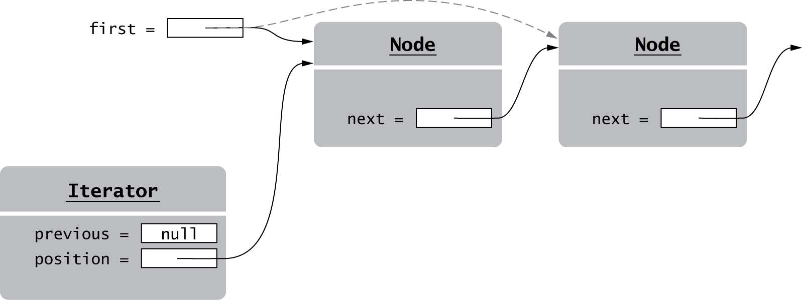

Now suppose we call remove on the iterator:

if (position == first)
{
removeFirst();
}
else
{
previous.next = position.next;
}
position = previous;

As you can see from the drawing, position != first, and the second branch is executed. Because previous is null, an exception is thrown.

R16.11

public class R16_11
{
public static void main(String[] args)
{
LinkedList staff = new LinkedList();
staff.addFirst("Tom");
staff.addFirst("Romeo");
staff.addFirst("Harry");
staff.addFirst("Diana");

ListIterator iterator = staff.listIterator(); // |DHRT
iterator.next(); // D|HRT
staff.removeFirst();
iterator.remove();
}
}

$ java R16_11
Exception in thread "main" java.lang.NullPointerException
at LinkedList$LinkedListIterator.remove(LinkedList.java:163)
at R16_11.main(R16_11.java:14)

R16.12

Have the first iterator before the first element, and the second iterator traverse the first element of a list. Then insert an element through the first iterator. The figure shows the result.

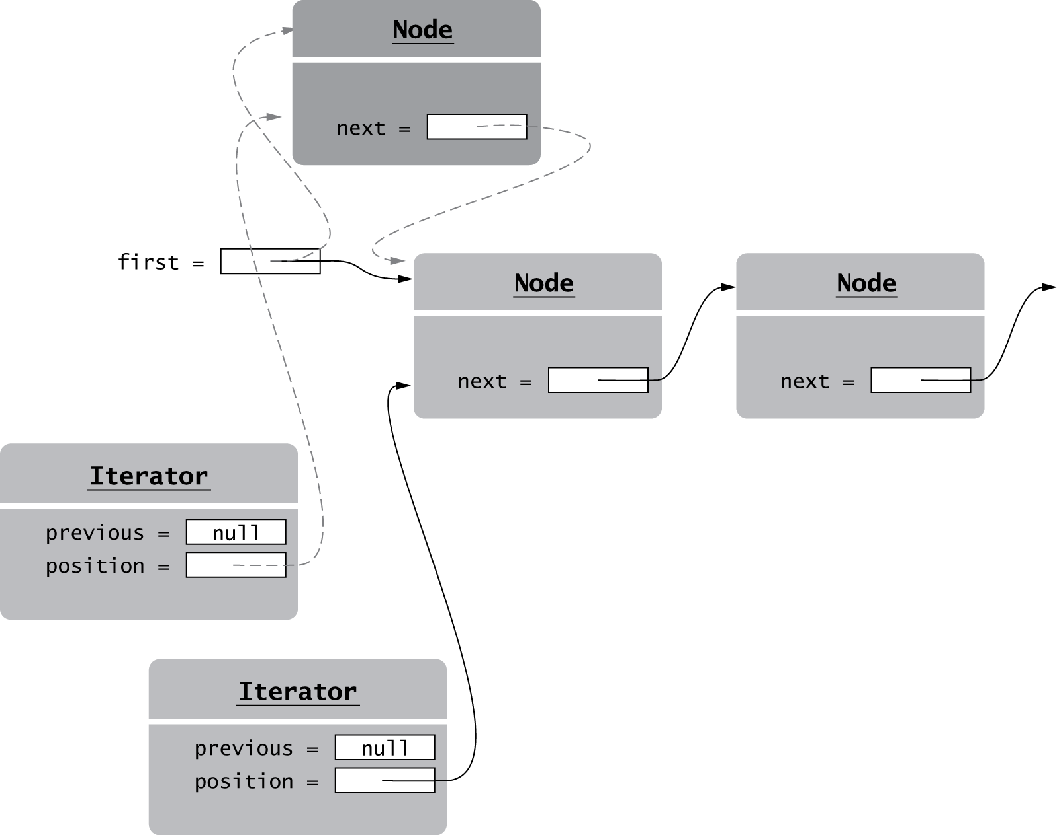

Now call remove on the second iterator.

if (position == first)
{
removeFirst();
}
else
{
previous.next = position.next;
}
position = previous;

As you can see from the figure, position != first, and the second branch is executed. Because previous is null, an exception is thrown.

R16.13

public class R16_13
{
public static void main(String[] args)
{
LinkedList staff = new LinkedList();
staff.addFirst("Tom");
staff.addFirst("Romeo");
staff.addFirst("Harry");
staff.addFirst("Diana");

ListIterator iterator1 = staff.listIterator();
ListIterator iterator2 = staff.listIterator();
iterator1.next();
iterator1.add("Fred");
iterator2.remove();
}
}

$ java R16_13
Exception in thread "main" java.lang.IllegalStateException
at LinkedList$LinkedListIterator.remove(LinkedList.java:155)
at R16_13.main(R16_13.java:15)

R16.14

Add a mutationCount to the LinkedList class. Add an iteratorMutationCount in the LinkedListIterator class. In the methods addFirst and removeFirst of the LinkedList class, increment the mutationCount field.

When you construct an iterator, set

iteratorMutationCount = mutationCount

In the methods add and remove of the LinkedListIterator class, increment both counts.

At the beginning of the add and remove method of the LinkedListIterator class, add the statement

if (mutationCount != iteratorMutationCount)
{
throw new ConcurrentModificationException();
}

R16.15

To get to the kth element of a list of length n takes O(k) steps if one starts at the front, or O(min(k, n - k)) steps if one starts at the front or back, whichever is closer. Assuming k is randomly chosen between 0 and n - 1, on average, O(k) = O(n / 2) = O(n), and O(min(k, n - k)) = O(n / 4) = O(n).

R16.16

The get operation is now O(1) since we can look up the link to n - n % 10 in constant time, and then make < 10 hops to get to n. However, maintaining that array of node references is very expensive when adding or removing elements in the middle of an array. For example, if one removes an element in position 19, all references to locations 20, 30, ..., have to be updated—an O(n / 10) = O(n) operation. In other words, we have lost the benefit of O(1) insertion and removal.

R16.17

As n elements are added, an O(n) resize will occur every 10 steps. Because Big-Oh discards constant factors (in this case, 1/10), the result remains O(n).

R16.18

First fill the array with 10 × 2^{k} elements, so that it is just about to reallocate.

Then add one element and remove one. The addition reallocates, and the removal reallocates again. The cost is not O(1)—you can make it arbitrarily high by choosing an appropriate k.

R16.19

For each addLast operation, charge $2. Spend $1 on moving the value to be added to the end of the array, and put the other $1 in the bank. When it comes time to reallocate the array to one that is twice as large, you must copy n elements, but there will be enough money in the bank to pay for that.

For each removeLast operation, charge $2. Spend $1 on returning the removed value, and put the other $1 in the bank. When it comes time to reallocate the array to one that is 1/2 as large, you must copy n / 4 elements, so there will be more than enough money in the bank to pay for that.

R16.20

Moving the head element to the tail is simply q.add(q.remove()), also O(1). Moving the tail to the head requires a loop:

int n = q.size();
for (i = 1; i < n; i++) { q.add(q.remove()); }

For example, if n = 4

A B C D
D A B C
C D A B
B C D A

The loop is executed n - 1 times, so it’s O(n).

R16.21

a) addFirst, removeFirst, addLast are O(1), but removeLast is O(n); see Section 16.1.8
b) All are O(1)
c) All are O(1+)

R16.22

No. There are two situations when head==tail: when the queue is entirely empty, or when it is entirely full.

R16.23

a.
1 2 3 4 5 _ _ _ _ _ currentSize = 5
H T
b.
1 2 3 4 5 _ _ _ _ _ currentSize = 2
H T
c.
6 7 8 4 5 1 2 3 4 5 currentSize = 10
H T
4 5 1 2 3 4 5 6 7 8 _ _ _ _ _ _ _ _ _ _ currentSize = 10
H T
4 5 1 2 3 4 5 6 7 8 9 10 _ _ _ _ _ _ _ _ currentSize = 12
H T
d.
4 5 1 2 3 4 5 6 7 8 9 10 _ _ _ _ _ _ _ _ currentSize = 4
H T

R16.24

You have stacks S1 and S2.

When adding a value, add it to S1. When removing a value, first check if S2 is empty, in which case you pop all values from S1 and push them onto S2. Then pop the value from S2.

For example,

S1: S2:
Add 1
S1: 1 S2:
Add 2
S1: 1 2 S2:
Add 3
S1: 1 2 3 S2:
Remove
S1: S2: 3 2 1
S1: S2: 3 2
Remove
S1: S2: 3
Add 4
S1: 4 S2: 3
Remove
S1: 4 S2:
Remove
S1: S2: 4
S1: S2

The cost for adding is clearly O(1), because we just add to a stack. The cost for removing is O(1+). We pay for transferring elements from S1 to S2, but that cost is amortized over each removal.

R16.25

You have two queues, an active one (A) and a temporary one (T). When pushing an element, add it to the active one. When popping an element, move all but the last element from the active one to the temporary one. The last one is the one to be returned. Then flip the active and temporary queues.

The cost for pushing is O(1) because we add to a queue. The cost for popping is O(n) because we need to move n - 1 elements to the other queue.

R16.26

It doesn’t work if one has different objects with the same content. Consider a hash set of Fred's favorite colors. You want to find out whether Fred loves green. No problem—look for Color.GREEN. But what about chartreuse? If you construct a new Color(127, 255, 0) to find out, then that object has a different ID than the new Color(127, 255, 0) that Fred constructed.

